OUTPUT SCREENSHOT:

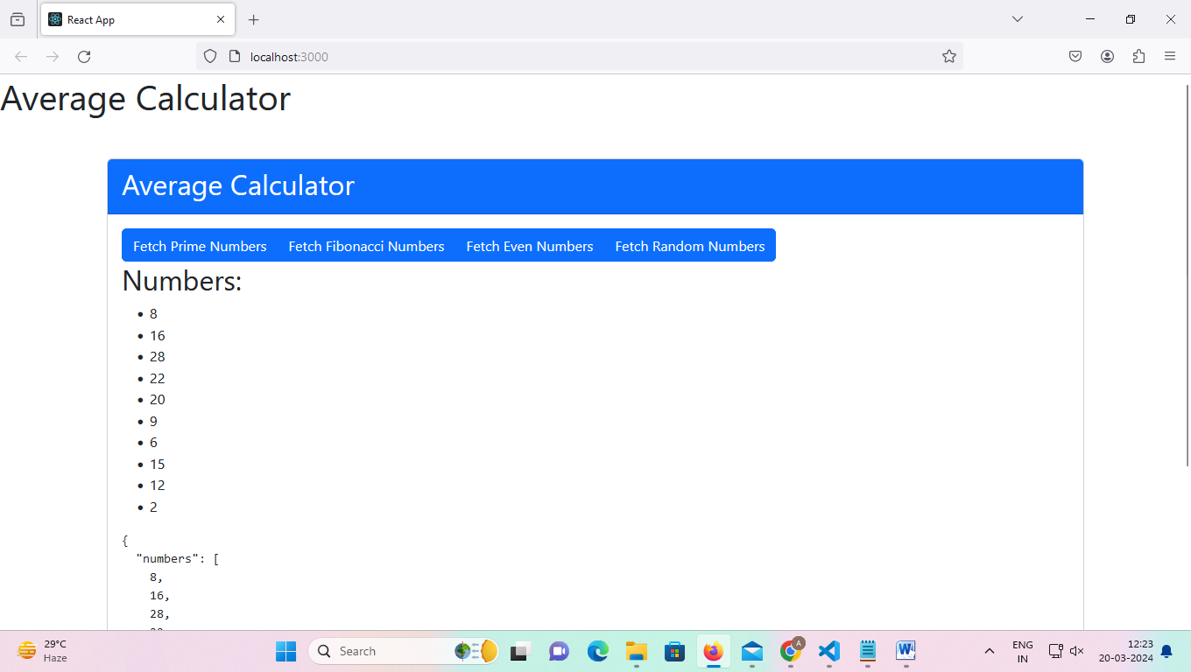

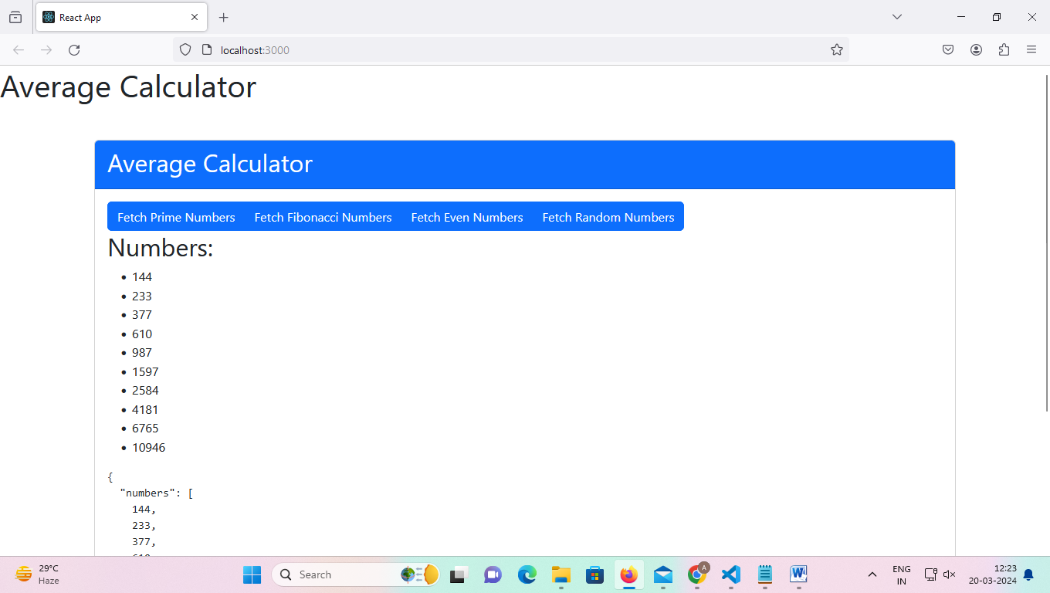

Response for prime,even ,fiboonaci and random numbers

Status: 200 OK

